How I Met My Husband
By: Betty Palermo (wife)

Tom and I met quite by accident. One of those nights when you aren't looking to meet someone but it just happens. We met at The Lodge, a nightclub that was in Salem. Tom was standing next to me as we watched the comedian on stage. He tried a little small talk with me but I am basically very shy using only one-word answers. He asked me to dance when the band started and after the one dance and he went to the bathroom I left and went to The Musketeer Inn also in Salem where my friend worked.
When I arrived, I told her about the cute guy I had met at The Lodge. She of course started on me about not knowing his name or where he was from or anything. "How are you going to see him again if you don't know anything?" she asked. "I am not looking to see anyone right now. I want to be single for a while" was my reply. Within 5 minutes who walks in the door but Tom. He saw me there and came right over and sat with me and that was all it took. It was one of those things, it was meant to be.

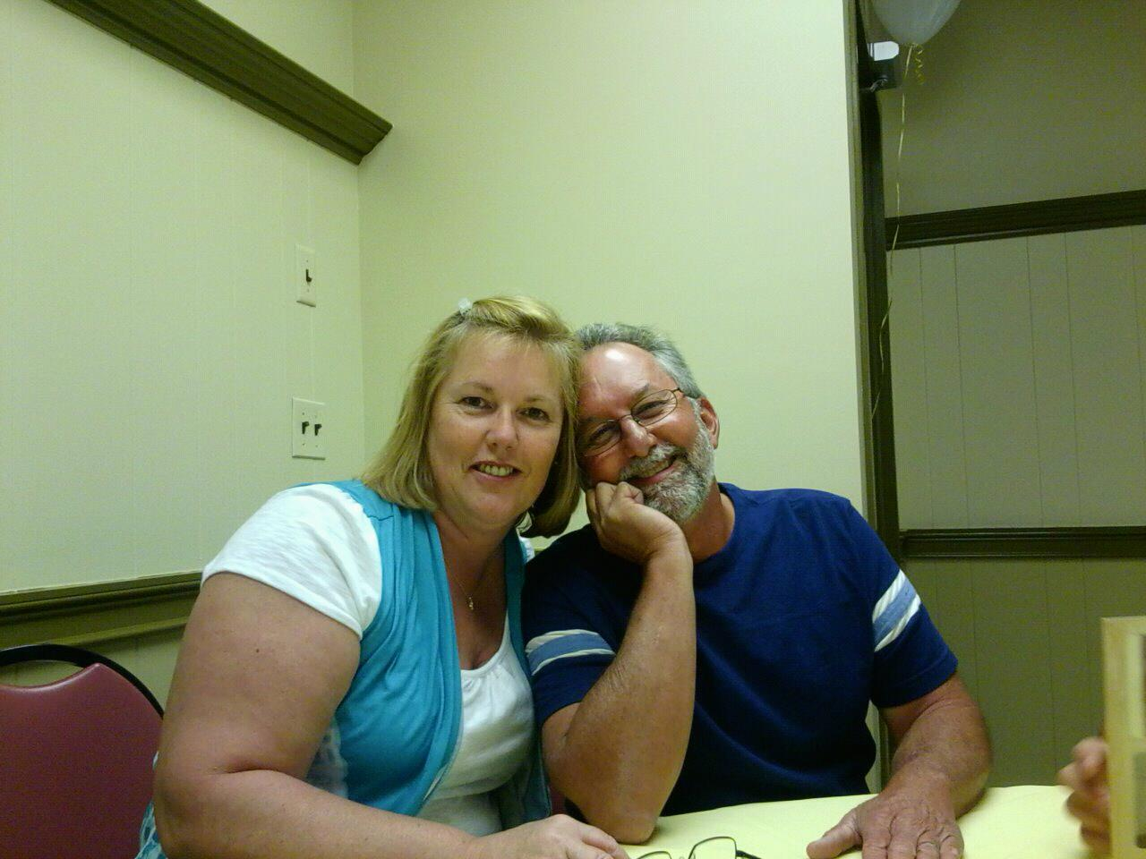
We saw each other almost every night from then on. We were engaged within 6 months and married less than a year after that.

Tom told me more than once how his mother kept telling him he needed to go to Church, as he will never meet a nice girl at a club. We did laugh at it though being together for more than 28 years; I guess it didn't matter where we met, but more, that we did meet.

Married for 27 years and having 3 boys (every time we move to a new house we had another son, so we stopped moving) was not always easy by any means. Tom was so proud of his 3 sons for sure. I can still remember the look that was on his face when his first son was born is beyond words. He was so proud and so happy. (He had told me from the beginning that our first son was going to be called Mario whether I liked it or not, he had such a way of getting what he wanted). The pride and respect he had for Garrick as he joined the Army wishing he had joined himself when he was younger. The happiness, pride and great relieve when Jacob was able to walk again after his car accident. Each son brought new and better things to our life. Though life was not easy living with 4 Italian men, we wouldn't have had it any different.

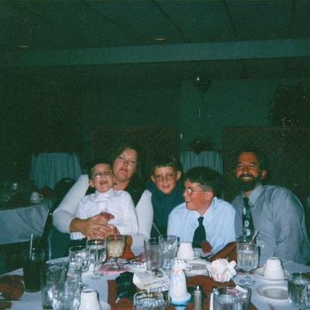
We have a lot of great memories to savor and share with each other this Thanksgiving.

My Brother Tom…I think we had a lot in common!
By: Loretta Packard (sister)
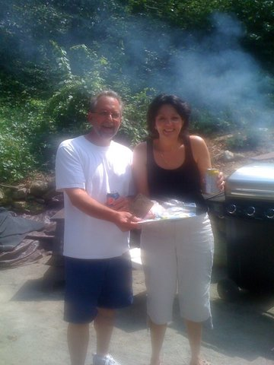
I do think we had a lot in common. We both like to give parties! I remember that whenever I would get up to speak at the party, trying to coordinate an activity or such, being real serious and all, he would always say something funny to make everyone laugh! . I wasn’t ever really sure if
he was making fun of me or not! He would shout out the funniest things and I found it hard to stop laughing and carry on with the important matter at hand! In this picture, we were having a cook-out for George and Diane for their health accomplishments. As I was flipping the burgers, Tom came over to me and said “you shouldn’t be doing this” and he took the spatula from my hand. I love you Tom!

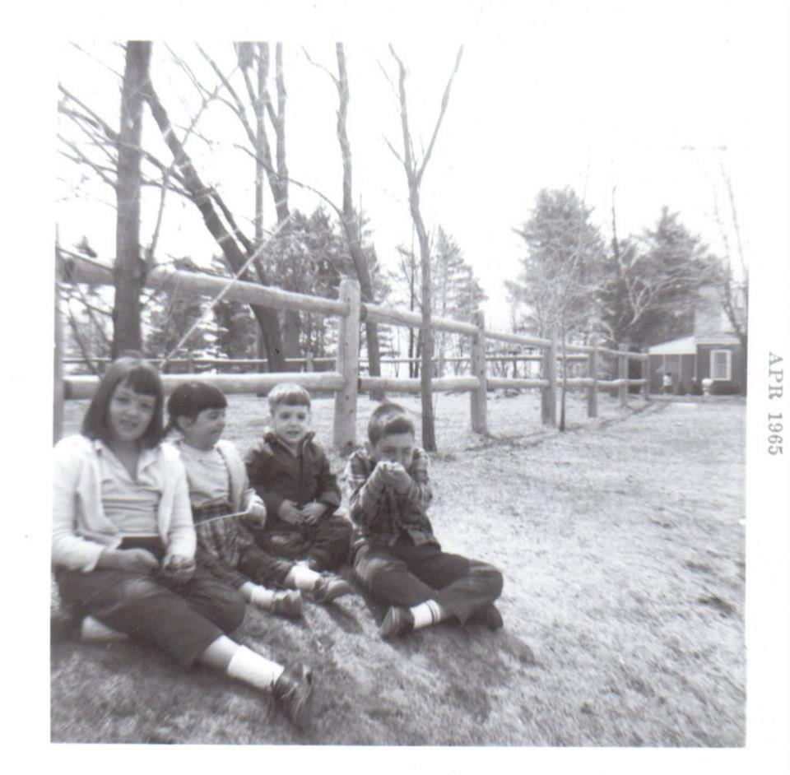
As you know we were 10 children and when we were young, I was the only chubby one and as you can imagine that wasn’t much fun! Tom was only one year younger than I and at one point, when he was about 10 years old, he had suddenly gained a bit off excess weight …and so he was chubby… just like me! I was happy to have the company! Then about a year later, he lost all the excess weight as fast as he had gained it and I was not so happy to see that!
We didn’t have a lot of toys as children and so we spent our days playing in the woods behind our house. There was a big rock that sat at the end of the field right at the entrance to the woods. When we were allowed to go out and play we would tell the others “we’ll meet you at the big rock!” All the neighbor children, including all of us, would meet at the big rock and then venture into the woods to build forts and play in the trees. One day, Tom and I were the only two waiting at the big rock and so we decided we were going to fix the broken stonewall nearby. We were about 10 minutes into this project when all of a sudden Tom dropped a huge rock on my right index finger. The pain was excruciating and I screamed all the way home to tell mama and get some help! I remember Tom running behind me but he didn’t say a word. I wasn’t sure if he felt bad or not or was just scared because I was screaming so loud! Anyway my fingernail turned purple then black and fell off a few days later.
For years I would compare my right index finger to my left index finger and always thought it was much flatter!
Not including that day, we had many fun days in those woods just being free to play simply… as children do!

It was a sunny day in August
When I got the news
That little Tommy had gone home
To Jesus in the sky
My heart was stabbed with a knife that day
That no one can every remove
And tears streamed down my cheeks,
…for long

And no one could ever soothe
There is an empty spot somewhere inside me
That nothing could ever fill
But my little Tommy he walks beside me
Still

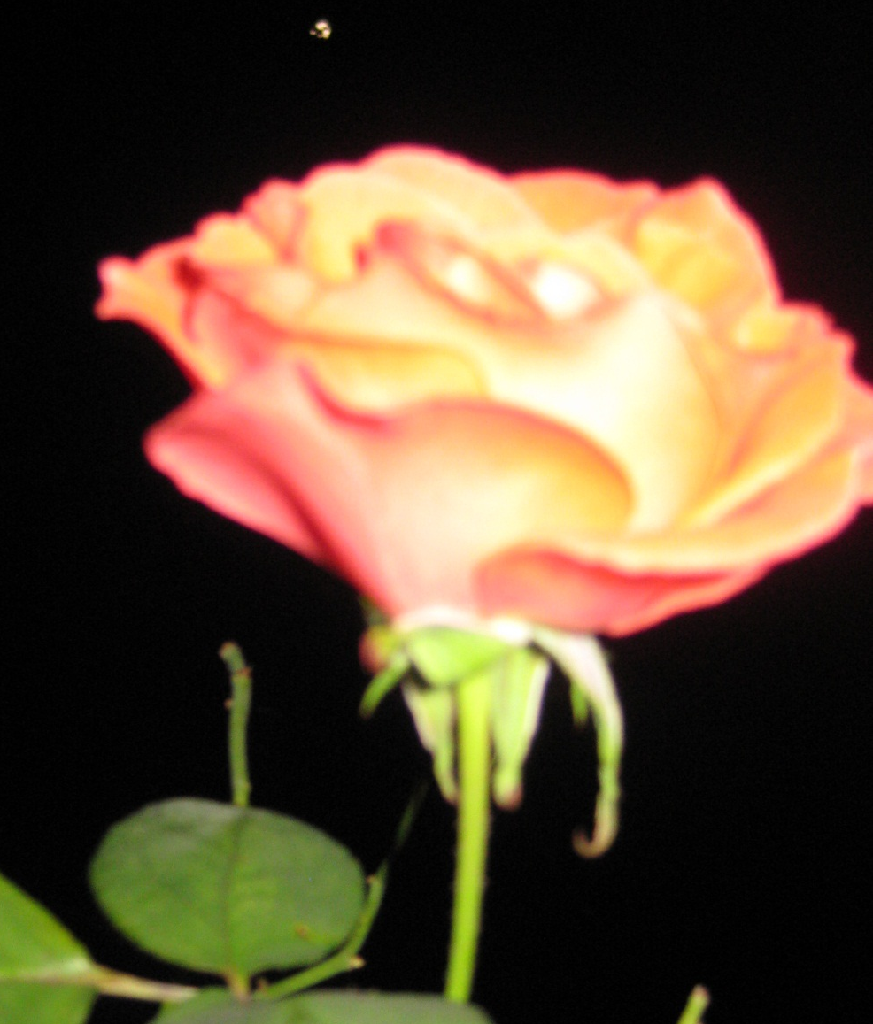
Tommy, please take this pink rose from my garden to papa… and kiss him for all of us! We miss you both so

Learning from my brother Tom
By: Theresa Robinson (sister)

I remember him being: Someone to look up to. He taught me how to climb a tree, how and where to go to get the most candy on Halloween, how to make a snow fort, how to drive the "pung-pung", taking me for a ride and teaching me how to drive his mini-bike, taking me for rides on his motorcycle, how to use a hammer and nail - although I ended up losing a thumb nail in the process - when he hit my thumb instead of the nail! how to please Papa -by talking about and doing things that interested him, how to be "tough"/argue/being mischievous.

We used to wrestle and argue about various things. - his wanting to use my "old/used/embarrassing to be seen with trumpet"...yanking it back and forth, until we both let go of it at the same time, causing it to crash to the floor, causing the bell part to crinkle and bend...leaving it in even worse condition than it was already in!

Playing on the swing set -calling my name and when I turned around, letting the swing bar go - hitting me in the face, chipping my front tooth!

Papa used to insist he take me to school in his car -he was a senior and I was a freshman. Being older, he didn't want to be seen with is little sister. He would let me get in the car, then as soon as we got out of sight from the house, he would drop me off. I would take the bus to school...lol...kids... What are you gonna do, huh?

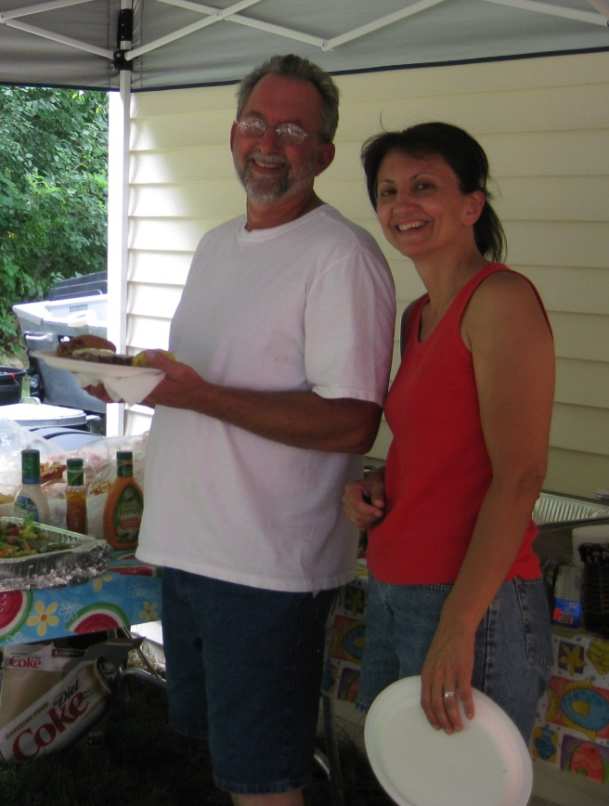
He taught me how to do a thorough cleaning. When John and I moved in this condo, Tom came over to help. He took all the windows out of the wall so he could clean them, as well as the window tracks they slide in, ripped up, rolled up and tossed all the old shag carpets in his town dump, used his “shop-vac” to "blow out" all the heat registers, then vacuum. When we had "the flood", from someone on the 3rd floor tossing stuff down the disposal, he helped and showed us how to replace the damaged wall sections and dismantled and assembled new kitchen countertops...including the sink!

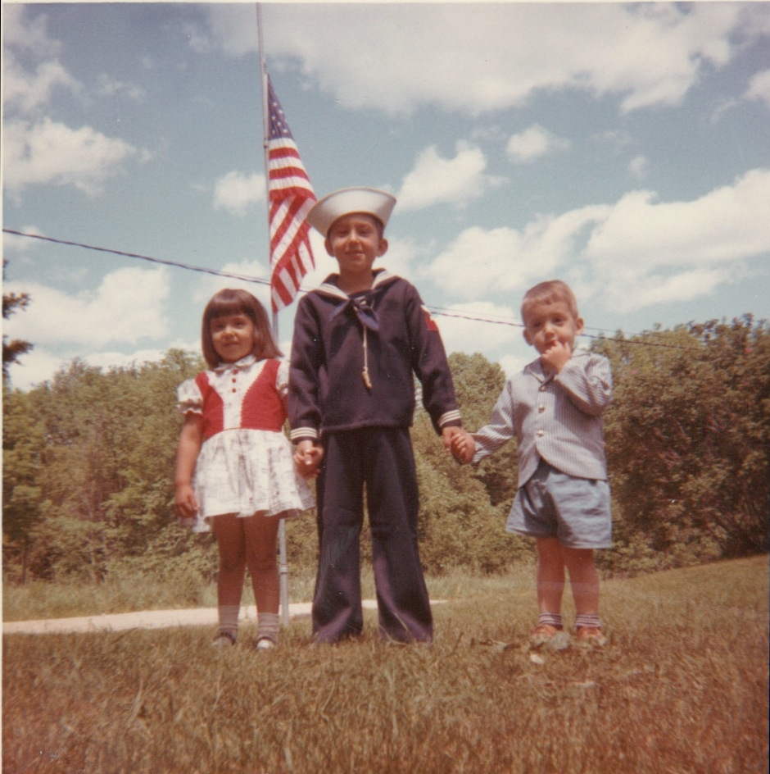
Tom taught me: It is fun to learn new things! It is nice to have someone to look up to, even if that means a few bumps, bruises and yes...a chipped tooth along the way!! When you decide to do something, put your WHOLE heart into it, no skimping! Have the smarts to ask for help...there are many others are very happy to share their knowledge...there is no need to feel stupid if you don't know how to do something. There is nothing wrong with being, at times, a bit "mischievous", enjoy every moment of life - none of us knows how much time we have left, you don't have to be sick to die, no matter how careful you are your life is not always in your hands alone… and finally...family sticks together...especially when you feel your world has fallen around you!!

Remember this...a beautiful caterpillar finds rest, becomes a cocoon, then a beautiful butterfly.

Tommy's body found rest and has become an angel.

Yes...you miss the caterpillar...but now it is a beautiful, free- flying butterfly...it can fly where it wants…no worries…no time…

Yes...you miss Tommy...he is now an angel...free from worry, time, pain, he sees Papa, uncle Guy, grandparents, friends...and yes...soon us…

BUT, most of all, he sees GOD, the angels and saints! THIS is what we were all created for in the first place… to enjoy heaven! Why would we wish him back to a place of worry and pain? We are all here "waiting"...our whole life is about going HOME! Where WE belong...where we ALL belong!

At the reunion party, Brandon came over to the table that John & I were sitting at. He sat on my lap and noticed my phone. He picked it up and started pressing all the buttons. He was being gentle with it and wasn't interested in making any phone calls. Somehow he found his way to the camera app. I thought this was really smart of him - after all, he was only 5 yrs. old at the time! He took a few pictures, which I must say were very good, minus a few that had his thumb in the way! He asked if he could take more but then I put him down and off he went.
A short while later he came back. He was excited to show us the pictures he took. I picked him up and John and I looked at the pictures. John and I started talking, while Brandon continued to "press buttons". When he had finished, off he went. I picked my phone back up, turned it back on and found that Brandon, somehow, had found a way to make the picture of the table next to us my phone’s background! Centered at the middle of the picture is Tom!

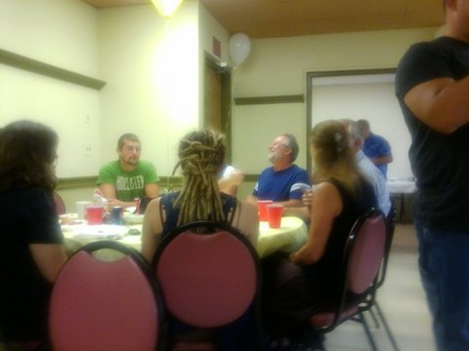

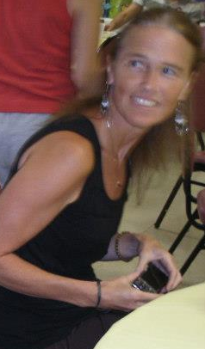

My Message for Tom and Everyone

By: Joy Palermo (sister in-law)
I just wanted everyone to know how wonderful it has been to be included into such a wonderful family, with the closeness and the love that everyone shares, with each other and with GOD.
It's not easy in this world to find the time to spend together, but somehow we all seem to keep each other in our hearts since Tom's sad and tragic accident. I think we all have realized the value of family and how it’s important everyone to find time for each other.
It has been an honor to be included in this family and I will miss Tom's humor, his laughter and his great smile and he will be sadly missed during all our “get-togethers”. I'm sure we will all always have a piece of Tommy in our hearts, and remember the things he would say and do and remember the signs he sent to each one of you during the course our busy days soon after the accident.
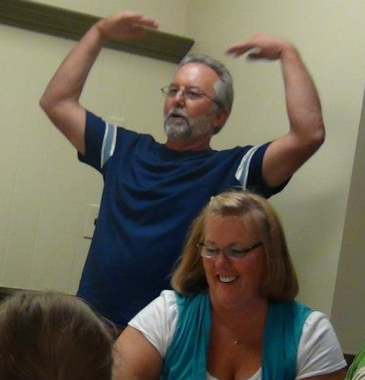
It was a rare gift from God that we all had that wonderful party - where we got to all see Tom a week before the accident (a party that your Mom had had a premonition to have!) She has God always close to her heart and mind and she sees more, even with her not being able to see, than anyone that I have ever known.

Tom will always be in our prayers. :)
Lots of Love, Joy

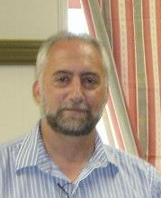
Remembering Tommy
By: Bob Palermo (brother)

I remember when Tommy used to drive the Redimix trucks. We would always look to see each other’s truck on the road - this went on for a few years. I only passed him once in Nashua, NH, a long time ago. I continued to look for Tommy, for the longest time, but could not see him.
After Tom had passed away, I asked him one morning (in my mind), to show me a sign that he was with God. As I came to a red light, I had many Redimix cement trucks meet me at the intersection - which I thought was a little strange - and I had my doubts that it was a sign from Tom.

After making my delivery, I headed back to the same intersection and when I got to the exact same spot as before, again, I had many Redimix trucks meet me there.

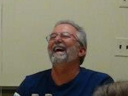
I felt it was as if Tommy was saying, "Bob this is your sign that I am with God, you doubted me the first time when you saw the cement trucks, so here is a second sign. I am still here for you to see on the road, I’m everywhere.” It was almost as if I could hear Tom saying this.

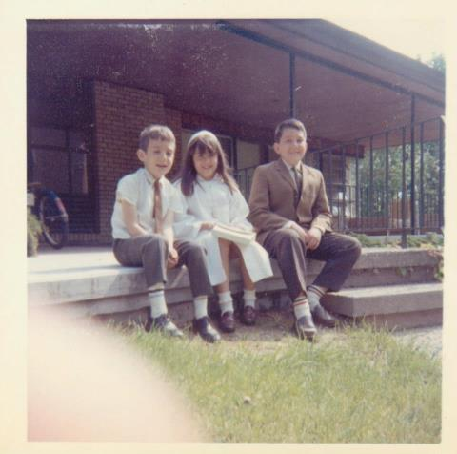
After having this experience, I felt that this was my sign that I asked for, and I do believe he is with God.

Love, Bob

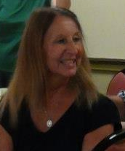
My Message from Tommy
By: Antoinette Mondalto (sister)

It’s hard to write in a few words how it happened, but on Sept. 1st. the Saturday after we said good-bye to Tom, Jamie and I were walking along Nahant beach way, a long walkway along the ocean. The ocean always seems to bring comfort and put things into prospective for us.

As we walked, we talked over many things, but at that time Tommy was not far from our minds. We were a little quieter than usual.

At the end of the walkway, just before we turned around, an older lady came out from behind the tall ocean shrubs and overgrowth. There was a stone marker within the tall thicket, which we knew, but never attempted to read because of its density and its questionable tick inhabitance.

The woman asked if we were from Nahant and if we knew what was on the stone plaque? We answered no to both questions, but she was unable to contain herself, anxious to let us know what she had just read (she reminded me of Loretta). She said it reads, “for every joy that passes something beautiful remains".

It sounded like something a little angel would say about Tom. A little message from him to let us know he was safe and in a good place. We thanked her and she said she was so grateful that we shared her excitement. I couldn't help but feel that Tom was there - telling us not to worry - helping us to heal our broken hearts. Aileen later found the entire saying that is engraved on the rock. It says:

The Tide
The tide recedes, but leaves behind bright seashells on the sand.
The sun goes down, but gentle warmth still lingers on the land.
The music stops, yet echoes on in sweet, soulful refrains.

For every joy that passes, something beautiful remains. 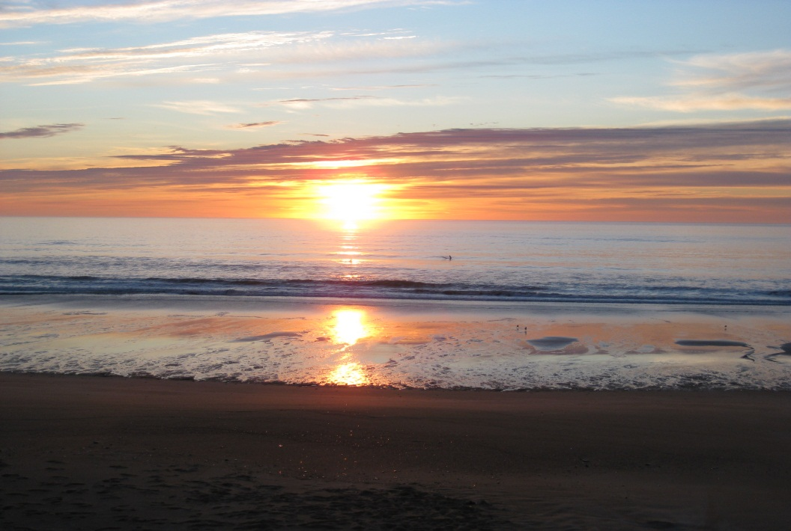
How brief and precious our time is here. Love, Antoinette

Remembering Tom
By: Kathy Palermo (sister in-law)

The Chair
Several years ago, probably 25 years or so, I bought Louie an outdoor chair for the yard. Steve and I found it at the pool store and it looked a lot like the “Captain’s Chair” on Star Trek. Louie being a Star Trek fan, I thought what a perfect gift however it needed to be put together. I struggled with the directions and had all the parts laid out but it look impossible so I called Tom who was living about a mile from us at the time on James St. Tom came over and in no time he had the chair put together so that we could surprise Louie with it for his birthday. It has always been outside and it has weathered many climates. The chair pads are long gone but the chair is solid. It has, over the years, been Louie’s relaxing chair, thinking chair, basically his comfortable place to sit. We still have the chair and over the years have been thankful for Tom’s many kind gestures when we needed his help.
The BOAT…
Back in the 70’s when Louie and I were first married, Tom was a teenager and always had bright ideas for an adventure. He went out to Kmart and bought a 2-man boat and asked Louie to go launch it on Canobie Lake at the boat ramp. The two of them took off on this short adventure on the lake only to find that the two-man boat was barely sturdy enough for 1 person! They were cramped into this small space and it floated low in the water with the weight of the two of them. As they paddled around the lake, the water from the waves bounced them all over the place and the waves hit the bottom of the boat,which became very uncomfortable. Water came inside the boat and they decided to end the ride shortly after they left shore. When they got back to shore, Tom said his great idea was a bust and Louie helped him dry off the boat, folded it back up and packed it in the box it came in. Tom returned the boat to Kmart the same day. Again, Tom’s infectious laugh made the retelling of the story a great memory for years.
Tom to the rescue…
Tom has always been willing to help anyone out when they called him, even if it was in the middle of the night. When Louie was first on the Police force back in the mid 80’s, I got a call from the police department to say he was “en route” to a call when the front right tire of the cruiser he was driving was later found defective and he had a blowout while traveling on a back road going over 40 MPH. He was taken by ambulance to St Joseph’s Hospital in Nashua at about 2 AM. I woke Steve up and got him dressed but I was so upset that I could not drive us to the hospital. I called Tom and Betty, who were still living on James St in Derry NH and they got out of bed, picked us up and drove us to the hospital. They waited there with us and occupied Steve while I checked on Louie’s progress. They stayed there until Louie was ready to be discharged and then drove us all home. Louie by the way had about 20 stitches in his head from hitting the windshield.
There are many stories about Tom and his cars. Some of my memories are vague but perhaps someone could help fill in the blanks on a couple of issues. I remember Tom had a great love of fast cars and that he had several Chevy Novas over his teenage years. One day he came back to the house on North Policy St and said his wheel had come off down the road. It was so shocking and we wondered what happened! Not long after, on a different car but still a Nova, the same thing happened - another wheel came off. We wondered if someone had tampered with the wheels or if Tom just had bad luck with these cars! I do not remember the rest of the details of these stories but if someone else remembers them, it would be interesting to find out had been going on.
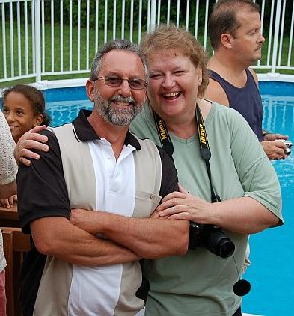
Another car story is of the antique car Tom had bought and restored. I do not remember the make and model but he ended up painting it a candy apple red. It was a really neat car. He kept it in our garage for quite some time while he worked on it - somehow, we never got pictures of it. And what actually happened to that car? I am sure Betty knows.

Remembering Tommy
By: Louie Palermo (brother)

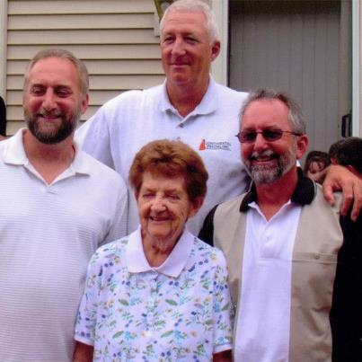

Well if I can remember correctly, of course this goes way back to the summer of 1970, I was working for Turners Dairy in Salem, NH. I drove a box truck and delivered milk to several stores and schools. Due to the schools being closed for the summer, they gave me a couple of day camps to make up for the loss of the schools. One of these day camps was called Camp Tel Noar in Hampstead, NH, a Jewish camp for boys and girls who ordered ice cream one day. Now due to this being a milk truck it was only refrigerated it did not have a freezer so of course the ice cream would begin to melt a short time after it was loaded. I would have to go to this camp first then finish my route.

Tom had been asking to go with me for some time, so I told him I would take him. It was probably around mid-summer because that morning was just plain hot, We got up at 5:00 AM and Mama would always get up and make us breakfast…couldn't ask for a nicer mom. We would then go to Turners and load the truck up for the deliveries and of course loading the order of ice cream at the end. Tom asked me if it was going to melt. I told him, I guess a little, but when they put it into their freezer it would re-freeze.

Well, when we got to Camp Tel Noar, I backed the truck up to the loading dock and the owner came out. I cannot remember what he looked like but I remember that he was always complaining about the milk being too warm or some of the 1/2 pint milk containers leaking from the top seal, but he always treated me nice. I guess he knew that it was not my fault. Many times he asked me if I wanted some breakfast but I always told him that I was on a schedule and really didn't have time. Anyhow, after backing up the truck, Tom and I jumped up onto the dock and opened the door. We pulled out about 4 boxes containing Dixie cups. The owner opened the box and pulled out a Dixie cup and pressed his thumb onto the cover. Due to the ice cream being pretty much melted the force of his thumb forced the cover down and Ice cream came out all over the place. He was pretty upset and began yelling. Poor Tom just stood there as if he was getting yelled at.

Anyway, to make a long story short, I guess the guy felt bad knowing that it was not our fault and asked Tom and I to stay for breakfast. I looked at Tom and his face expression was telling me to say no. I told the owner that we would like to but would end up being late on our route. He said ok but wanted to give us something to eat along the way. He went into the kitchen and came out with two 6 inch pies. One was blueberry and I can't remember the other.
As we left we looked at them and decided we would not eat them. I still remember just like it was yesterday, Tom said, "what should we do with them?” I told him when there is no one behind us to flip them out the window. Tom had this great Idea about trying to hit a sign with them, so as we passed a street sign, he flung out the first one and missed! We then came to another sign. It was a yellow sign indicating a turn ahead. He put the blueberry pie in his hand and flung it out. It struck the sign smack in the middle and slid down the sign leaving a huge blueberry stain! I'll tell you, that stain was probably there for 6 months! Every time I would go by it, I would laugh to myself and picture Tom's big smile when the pie hit the sign making one big mess!

Fun with Tom
By: Marie Carroll (sister)
Tom visited us in Rome back in the 70’s. We had such a great time. Our kids (Diana, Andrea and Sean) were little and the visit from Uncle Tom was so exciting! We played games and listened to the 60’s and 70’s music on the radio.

Another memorable visit was on a Memorial Day weekend when Tom, Betty, Mario, Garrick and Jake stopped by on their Niagara Falls camping trip. They parked their camper trailer out front. We had a picnic in our yard. Diana, Scott, Leanna and Natalie joined us for the picnic. There were the regular hamburgers, hotdogs, etc. ... but the highlight of the picnic was “salt potatoes”! Tom had never eaten them before and he thought they were the greatest! On my next visit to Salem NH, I brought several bags of “salt potatoes” for Tom. Now, whenever I eat “salt potatoes”, I think of Tom!

During one of my visits to Mama, Tom came over on a Sunday. (When I visit, Sundays are usually reserved for sisters, brothers, and their families to get together at Mama’s.) That particular Sunday, Tom brought a projector and some “old” movies. It was fun seeing Papa, Mama and all the “kids”. Some movies were of weddings, birthdays, and picnics. Many were just enjoyable times inside our house – especially at the kitchen table.

This past March, I had a “fun time” with Tom at Chris and Stacy’s wedding reception. The DJ had the guests play a game at each table. Tom was sitting at the same table with Mama, Carolyn, me and other family members. I can’t remember the exact game. I think we passed two items around the table and when the music stopped, the two people who were holding the items, were invited onto the dance floor. Tom and I were the winners at our table. I thought we were going to claim our prize. Little did I know that we and the other winners from other tables were now involved in a dance contest! I was about to head back to our table when Tom said “come on, stay. You can do it!” So we did. We won the dance contest and were crowned king and queen of the dance floor! 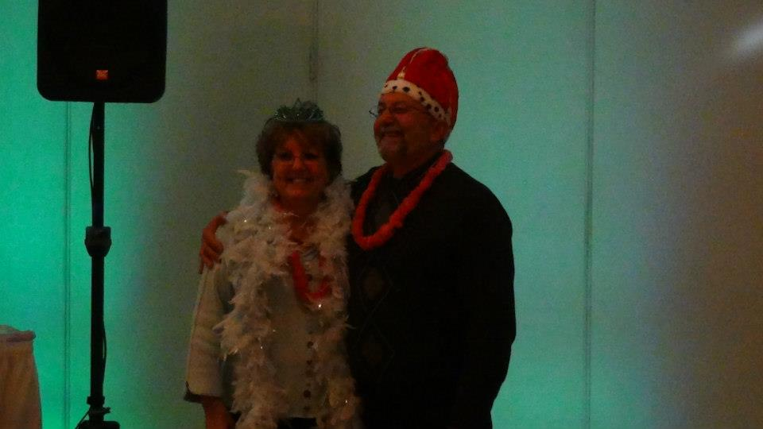

I was a little embarrassed but it was fun doing this with my little brother ---- and I have pictures of the memorable event to treasure.

My sign from Tom:
I want to thank you for “my sign.” Soon after you left us, one of our family members told us they received a “sign” from you. This assured them that you were in heaven. This sign involved seeing several cement mixer trucks at an intersection on the way to work. This person also saw them again at the same intersection on the way home from work.
I prayed that you would also send me a sign. It would probably be different – not cement mixer trucks. I don't see cement mixer trucks very often. I can't remember the last time I saw one.
I spent some time at Mama's after you left us. I eventually had to return to Rome on September 4th. Right before I exited the New York State Thruway, taking the Utica exit toward Rome, a cement mixer truck appeared in front of me. I had not seen it earlier. It took the Utica exit, followed by me! I next had to take the Rome exit. It took the Rome exit in front of me! At that point my cell phone rang and it was my son. I talked with him a little then said, “I have to hang up. I have to follow the truck in front of me.”
I knew that I had to pass the truck to get a glimpse of the driver. As I passed, I looked at the driver's side window. The head was dark and I could not make out any features. But I knew it was you, Tom. Your head was dark and featureless because you weren't really there in person, but your soul and spirit were there. The truck then took the next exit. I smiled and headed for home knowing that you were okay and in heaven.
Thank you Tom, I miss and love you so much. You are always with me.
Your big sister,

Marie.

Our Tom in Every Tomorrow!

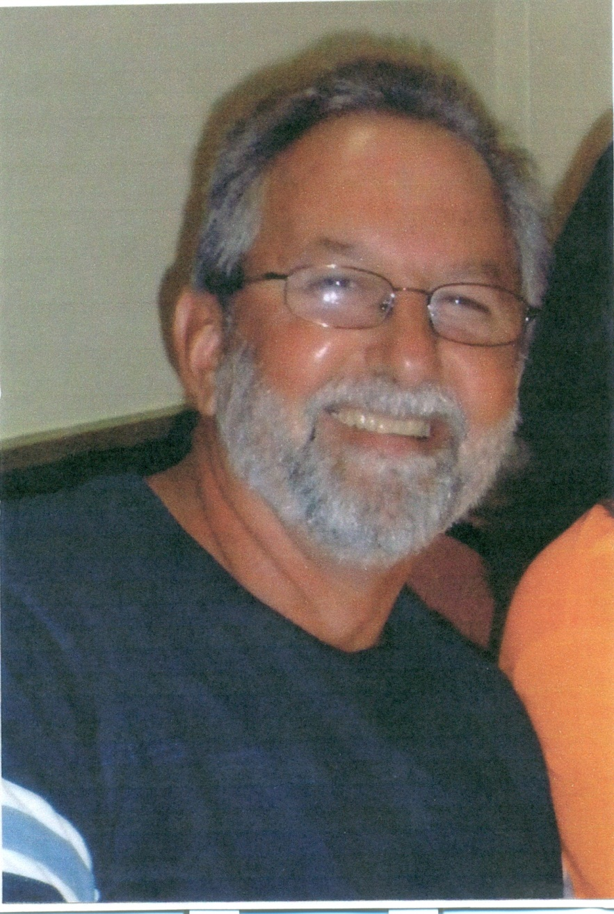

Holding you close to us always during Christmas time and always until we see you again in heaven!
Love,
Your Family!

Memories of Tom
By: Diane Palermo (sister)

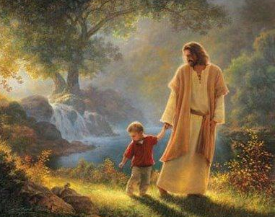
I remember when we were little and it was Mother’s Day. We had nothing to give Mama so Tom and I came up with a great idea… we walked down the road near our house and picked wild flowers from the fields. We were so proud to give her this gift and Mama was very happy to get the beautiful wild flowers!

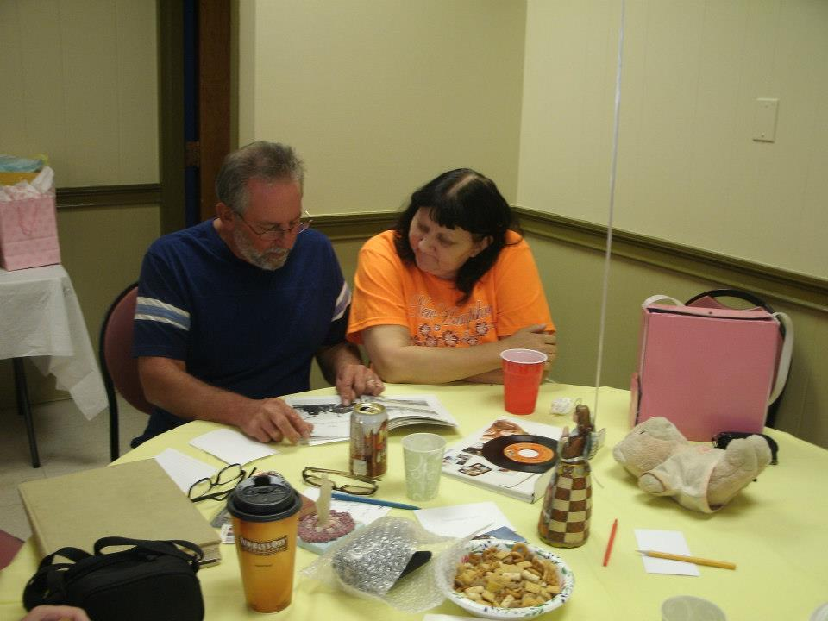
I remember we had raincoats… Tom had yellow, I had green and Loretta had pink. They came with matching hats! We thought we were something special when we wore our raincoats! I can still remember....................... the smell of those rubber coats……. Actually


I miss that smell! Love, Diane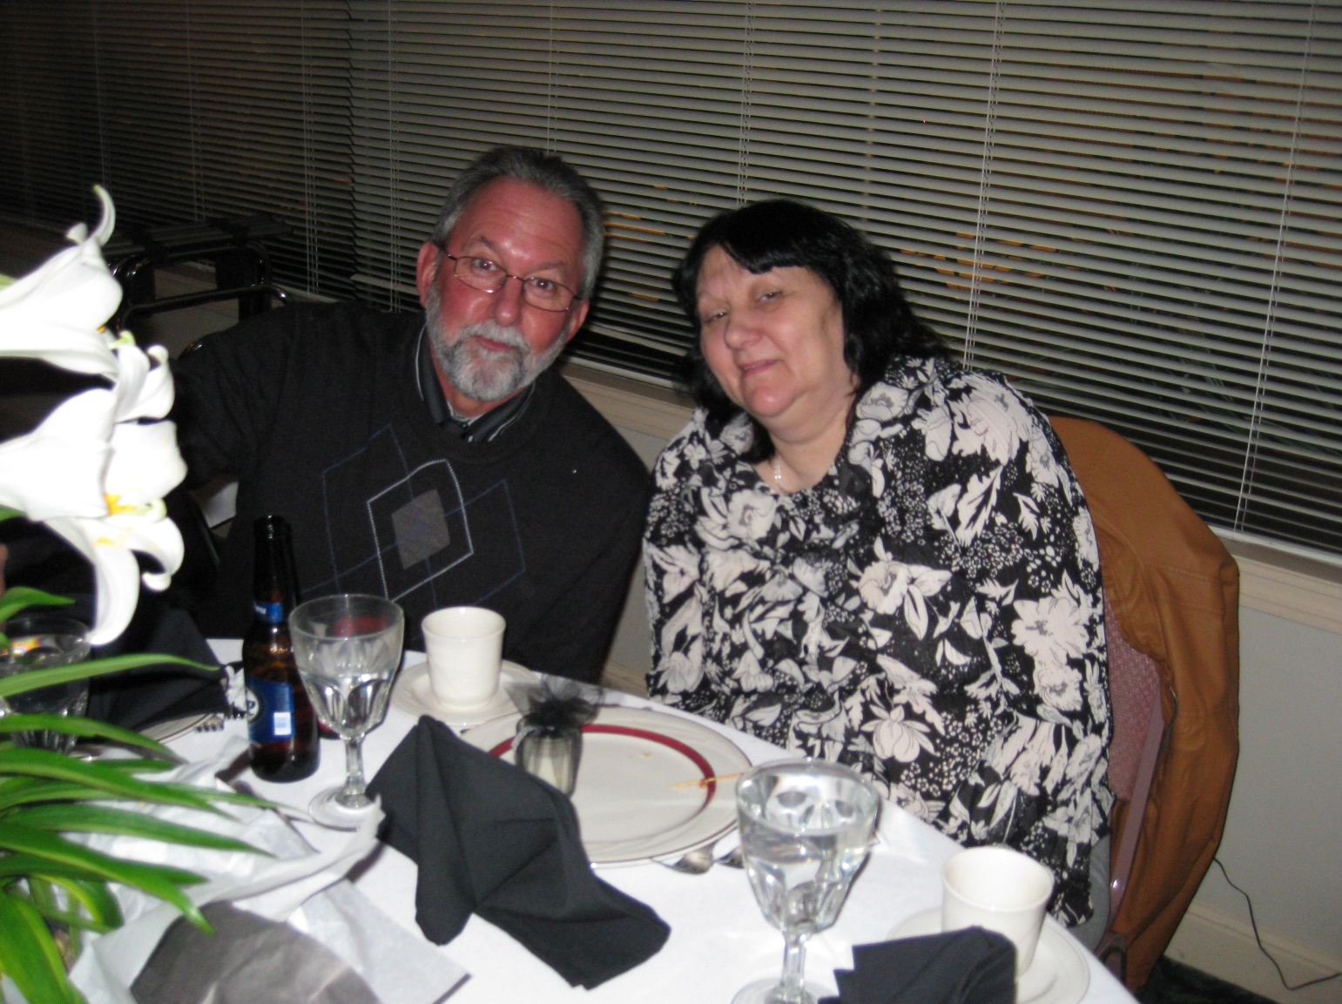 

The Road
By Roberta Hatch (sister)

When we were small at Mama’s and Papa’s house we made up a game we called Roads using the flagstone flooring that surrounded the fireplace. The flagstones were the landmarks (houses) and the spaces between the flagstones were the roads. Diane would set up her plastic farm animals on one of the flagstones for a farm. We would use little cars to drive around the stones while playing on our hands and knees… it was like a little town. We loved this game and played it often. We used to crash our cars into each other and Louie would be the policeman and pull us over for speeding. We had lots of fun for many hours playing Roads!

Some roads were long and some roads were short, just like life…

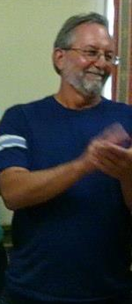
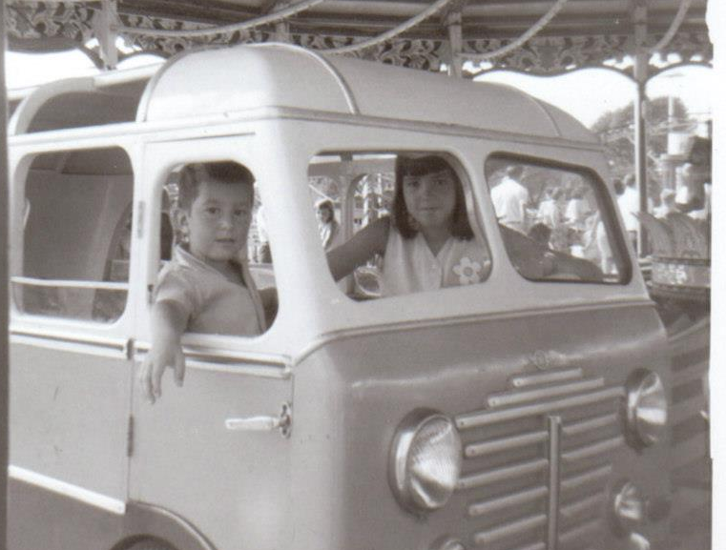

But, I know in my heart, we will all meet again one day and we will play the game of Roads once again!

My brother Tommy
By: Carolyn Palermo

One day I saw a wooden closet on sale at Kmart and I thought it would be good for my apartment. Tom helped me out with this; he picked it up for me then took it to my apartment and put it together for me. I really appreciated that he did that for me.
When we were young and lived together at Mama’s and Papa’s house he was always very busy and would leave his bed undone and his clothes everywhere… you know how boys are! I would hang his closes up and make his bed so he wouldn’t get in trouble!
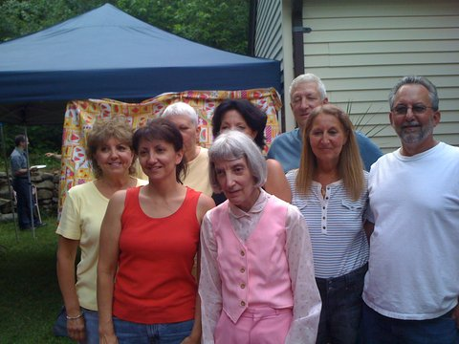
I guess you could say we were there for each other!

At the family party Tom was giving out the presents and when it was my turn to pick a present he showed me which one to pick… it was a big one… he said it would probably be a decoration because he knew I liked to decorate my apartment. So, I picked the one he told me. It was a wooden angel!

Sometimes he would call me up when I least expected and he would say: “What’s up?” Then we would talk and I would tell him what was going on. I miss him very much! I pray for him. I know he is with God!

“Tommy”
By George Packard (brother in-law)

Tom was an inventor like his father Carmelo. He loved to tinker with “stuff”. .

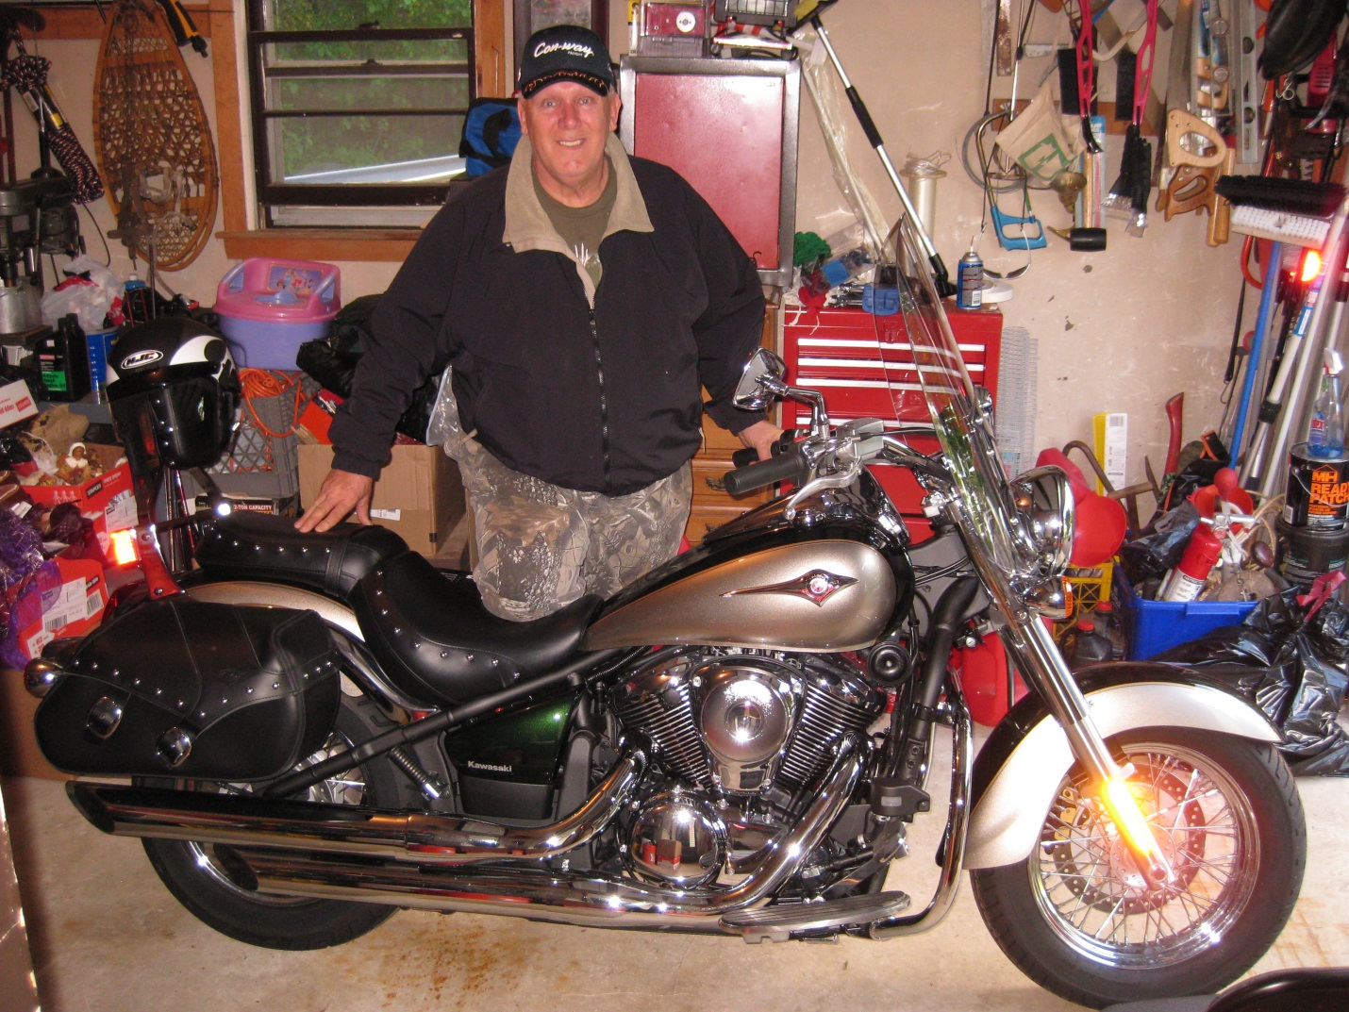
“He would take somethin’ that was nuthin’ and turn it into somethin’!”
He invited us to his “winter cookout” one year. We had never been to a cookout in the snow and so I wasn’t really sure what to expect. It was really cool. He had a fire going and well… it was a cookout in the snow! It was a lot of fun! His dogs were invited too and I remember how proud he was when he explained to me how he cut and sewed the dogs’ winter coats from two old sleeping bags! They came out pretty good… really warm! I told him he was “smarter than he looked!” Another great idea was using the pool cover as a canopy for the summer cookouts! He was really a smart man, funny too! I’m gonna miss him!

“My Tom”
By: Mama
Tom was busy working and he used to come see me off and on. He used to make me laugh and it felt so good to see him and hear his voice! Every time he came he would bring dessert and his favorite and my favorite were éclairs. We would eat them sitting down together. If felt like a holiday!
I remember him giving me a ride on his mini-bike around the driveway. I was afraid when I first sat on it. But then, I enjoyed the ride!
The day after he died, I was sitting in my chair. I wasn’t sleeping, and I heard him calling me. I heard him say, “Mama” ….nice and clear!
Love,
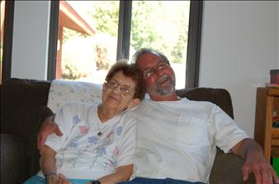
Mama

Remembering Tom
By Jimmy Gaudet (nephew)
“…Who wooda thought we’d be havin’ a party?”
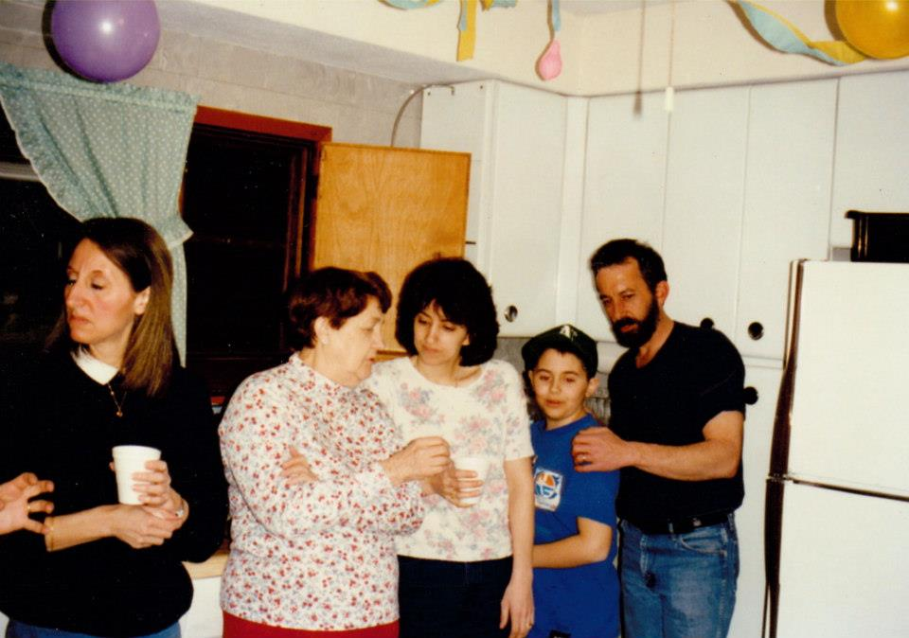

My Christmas Story for Uncle Tom
By Brittany Packard (niece)

I had been trying to put some deep thought into what I wanted my “Uncle Tom story” to be about. I was sitting on the chair next to my mom as she was telling me about different stories that family members already sent to her. I thought to myself nothing is going to be good enough, where do I even begin? My mother called me over to look at some pictures of Uncle Tom that someone had sent to her along with a sweet story. Suddenly there it was a picture of Uncle Tom at my baby shower! I thought for sure that was one of the most important times during my life and there he was! I remembered that at my baby shower my mother had passed around a book she titled “advice for the new parents” and a part of me was 100% sure that he had put some words of wisdom in that book for me.
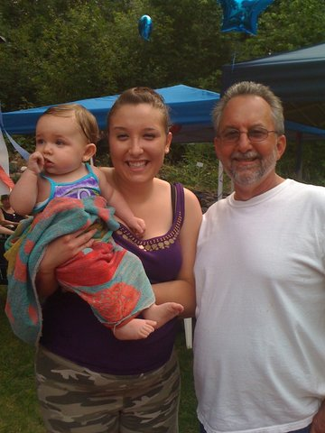

I wanted to get up and find that book right away. I sat there and thought maybe the book is in the shed, I’ll have to look for it this weekend because I certainly don’t have time tonight. I tried to forget about the book but I couldn’t get it out of my head! Every time I tried to focus on something else, something would nudge me and say “go look for it”. It was like Uncle Tom was bothering me to go find this book. It was the strangest thing, but suddenly I knew exactly where that book was, it wasn’t in the shed, I could see it in my mind. I jumped out of my chair, ran downstairs into my room, grabbed the box of stuff I save all the things I want Sophia to have when she gets older, tore the duct tape off like a child opening a present on Christmas morning, and BAM there it was! I opened the book and flipped around and there was Uncle Tom’s entry!

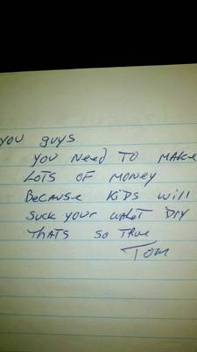

My Special Sign
By: Diana Kaufman (niece)

When I was about 7 years old, I had the honor of being the flower girl in Aunt Roberta's and Uncle Charlie's wedding. I wore my First Communion dress and carried a bouquet with yellow carnations in it. I honestly don't remember many of the details that day ... I guess that’s what happens after almost 40 years. But the one thing I remember vividly is riding in a car with my "Grandpa" to the church that day. My Grandpa passed away when I was 20 years old, but to this day, every time I smell carnations, I am instantly brought back in time to that special day and to my own personal memory of him.

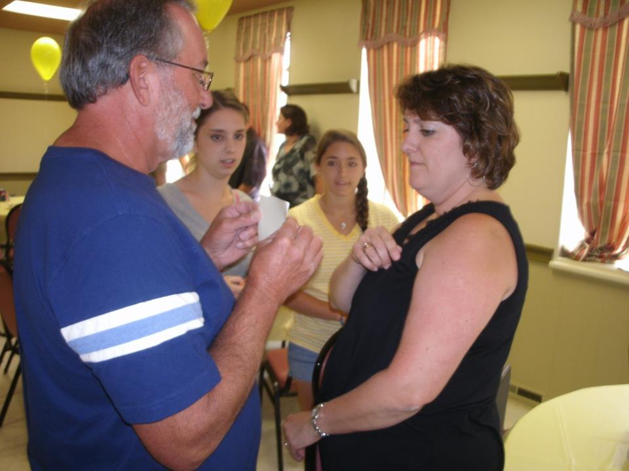
When Uncle Tom passed away this summer, we went to the cemetery after the funeral service, where Aunt Loretta passed out carnations to family members. One was given to me, but I realized that my cousin, Melanie, didn't receive one. Though Aunt Loretta still had flowers to give away, she wasn't near us at that point, so I gave my carnation to Melanie. Upon seeing that I did not have a carnation, my cousin, Jamie, gave me his flower. I stood there for several minutes, holding the carnation, listening to the words that were being spoken but never bringing the flower to my nose.

As the ceremony was winding down and family members approached the casket to lay down their flowers, I brought the carnation to my nose and smelled that sweet smell that reminds me so clearly of my Grandpa. In that instant, I knew Uncle Tom was okay; Grandpa had been there to meet him and show him the way. It was my own personal sign from Tom, or Grandpa, or both. But I left the cemetery feeling a sense of peace, knowing Uncle Tom was in good hands.

Love, Diana

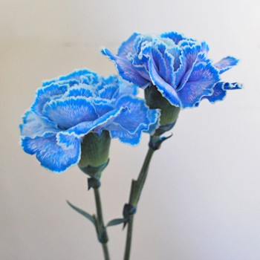

Dear Uncle Tommy by: Aileen Anderson (niece)
It’s me, Aileen your God Child. I am writing to you because there are a few things you need to know. I am so grateful for Grandma & Grandpa, two little angles, who gave me such a wonderful Uncle and Godfather.
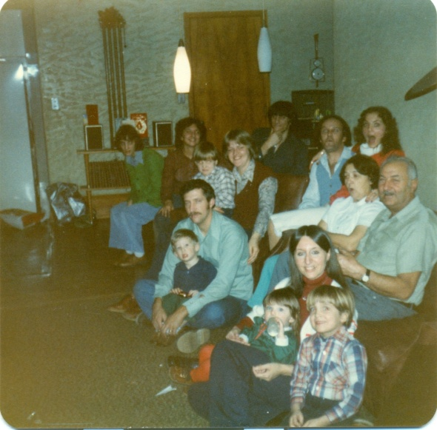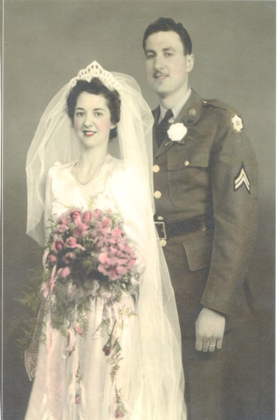
You told me I was your special little girl, as you are also special to me .
I just wanted to thank you being at my Christening, First Communion, and many Happy Birthdays to flollow.
I just wanted to thank you for my first piggy bank with my name on it, for my first pair of Strawberry Short Cake Roller skates, my Dollyand Me outfits, light blue with flowers.
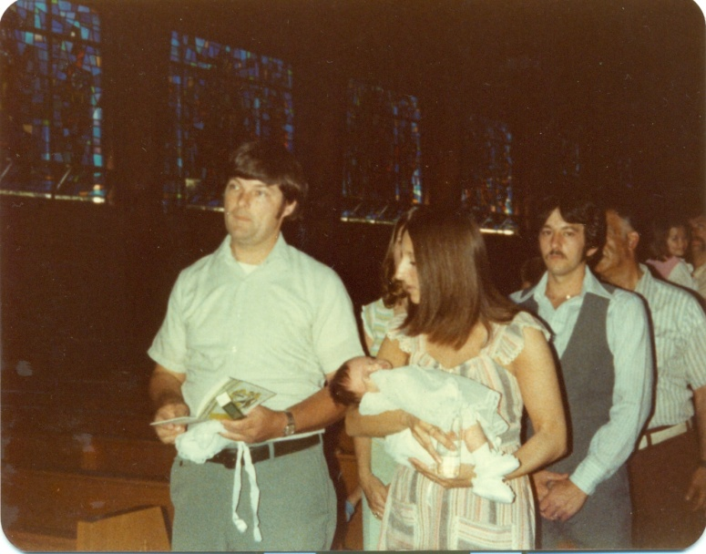
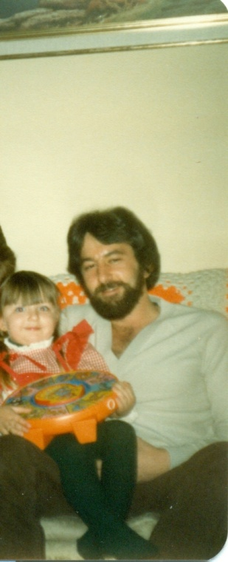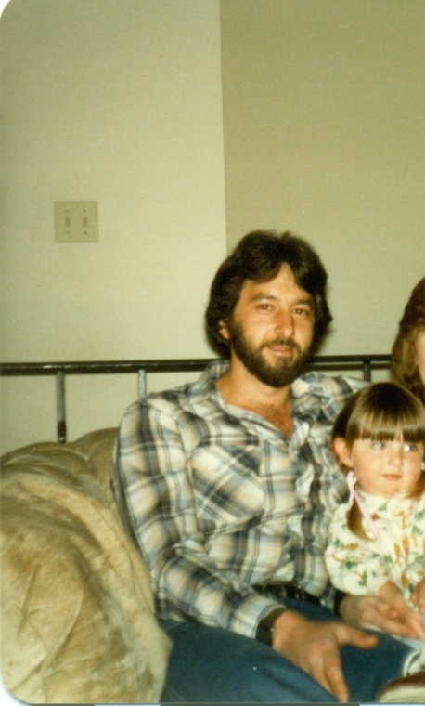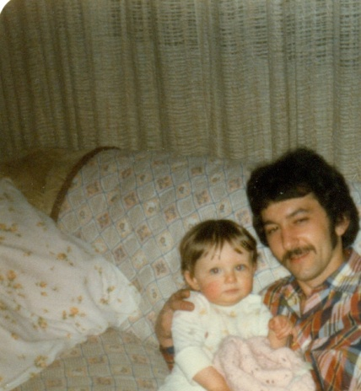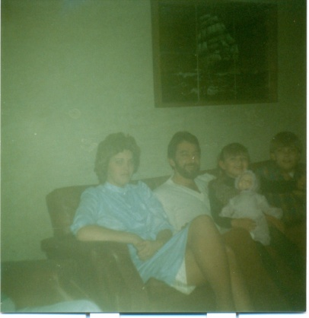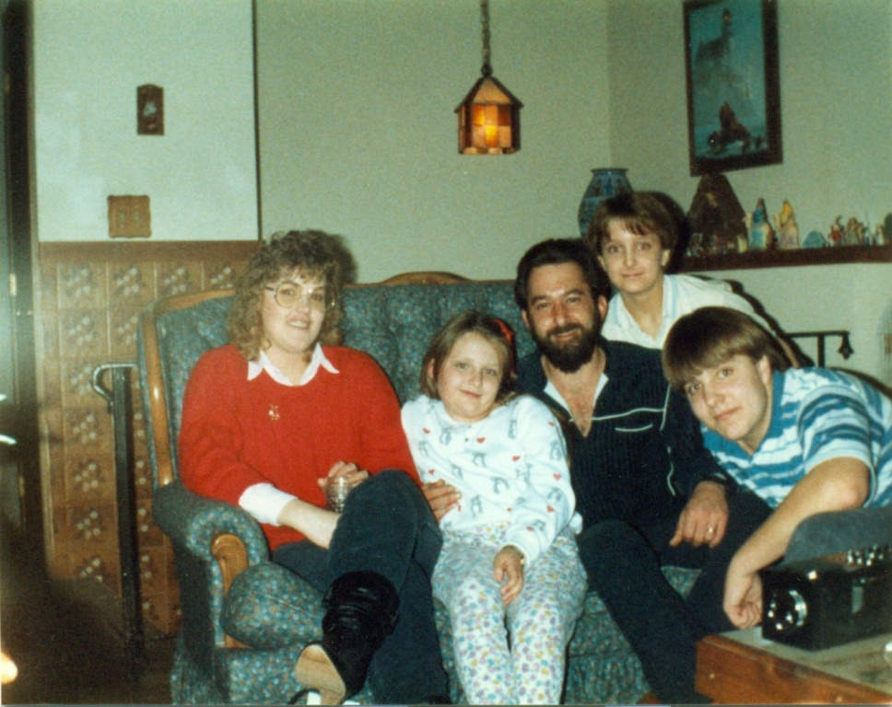
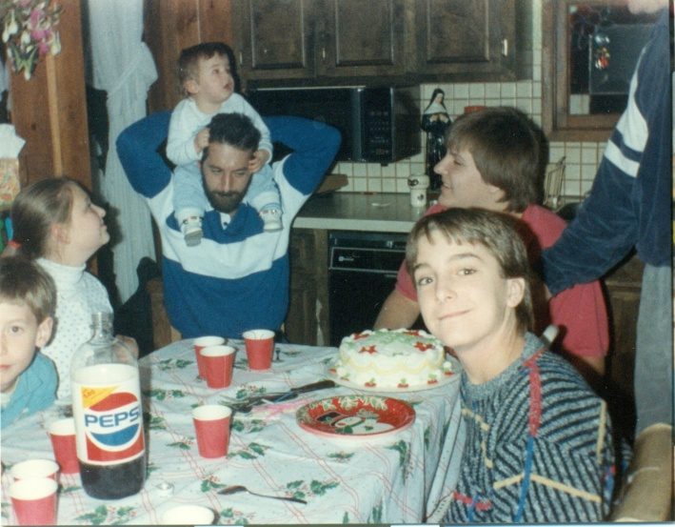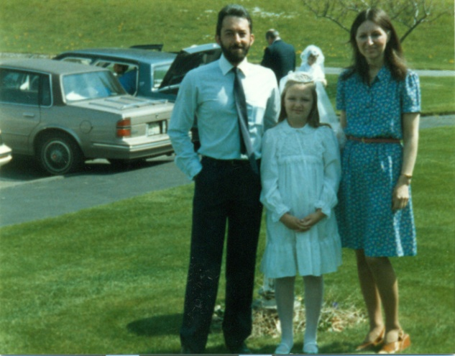

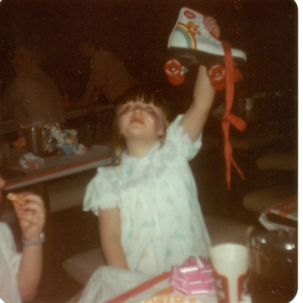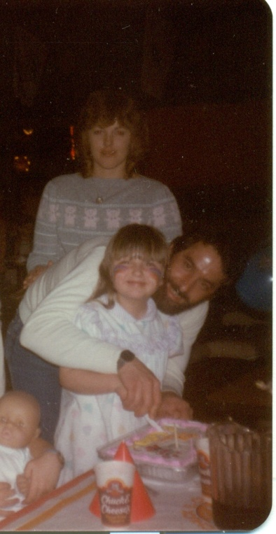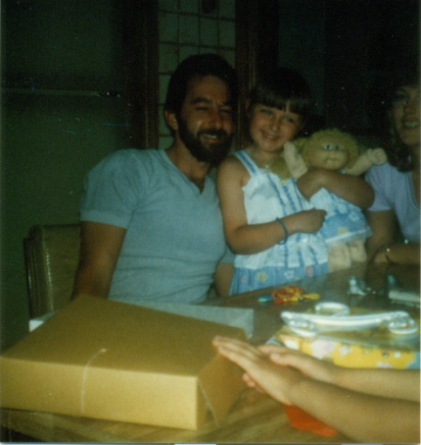
Just watned to say thank you for your Hugs and cute smiles
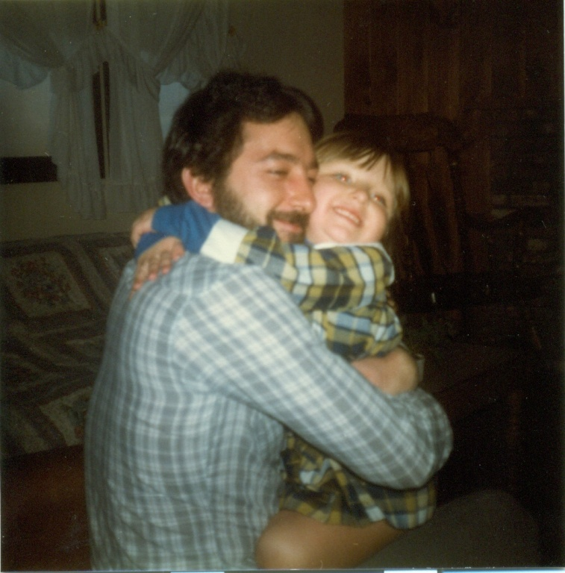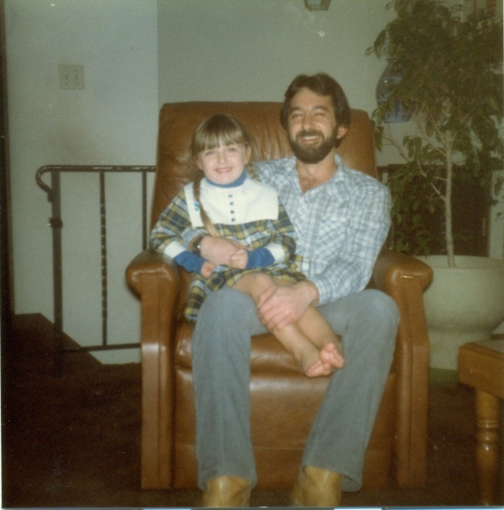
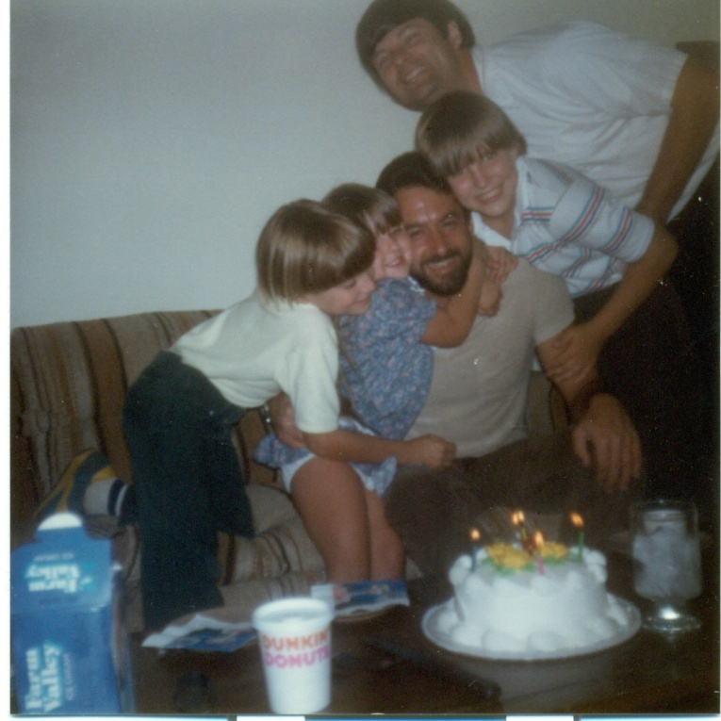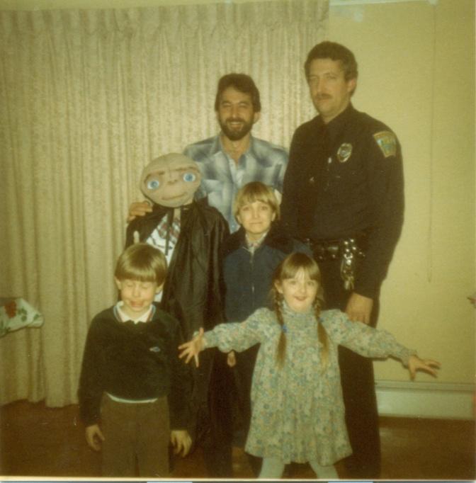
Just wanted to say thank you for your magical spoon on the nose trick!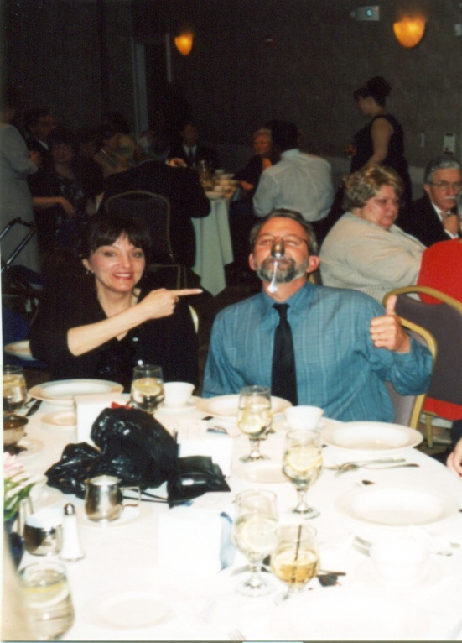
Just wanted to thank you for coming to my wedding.
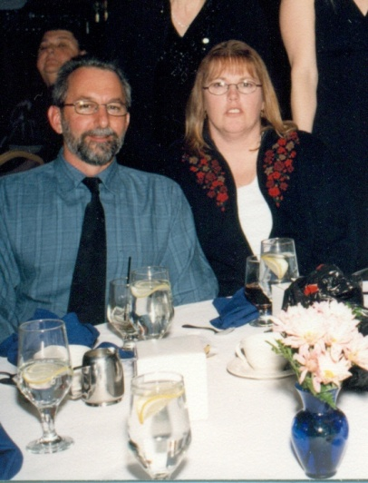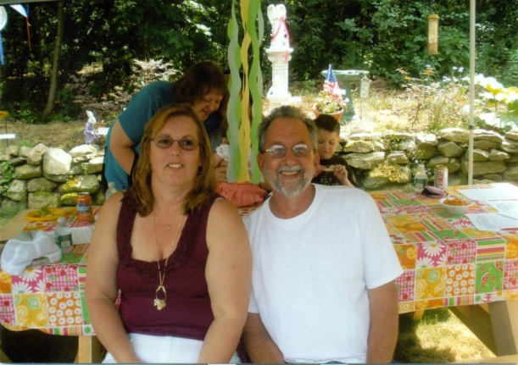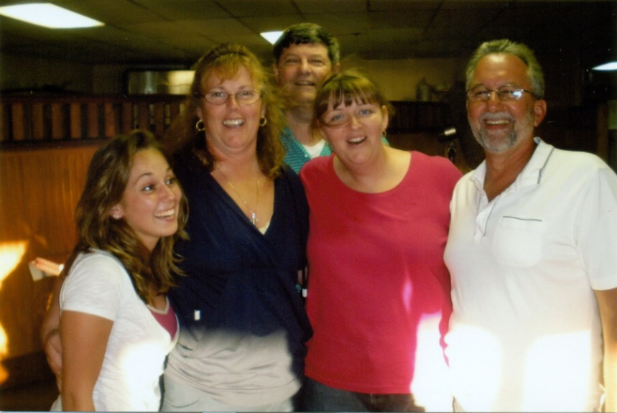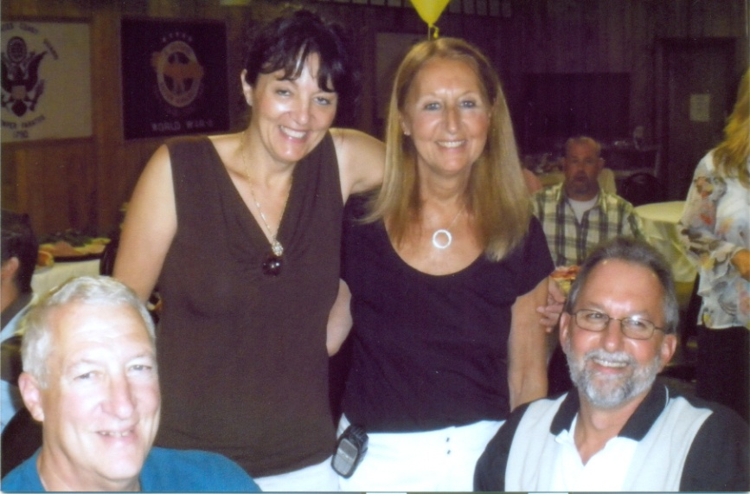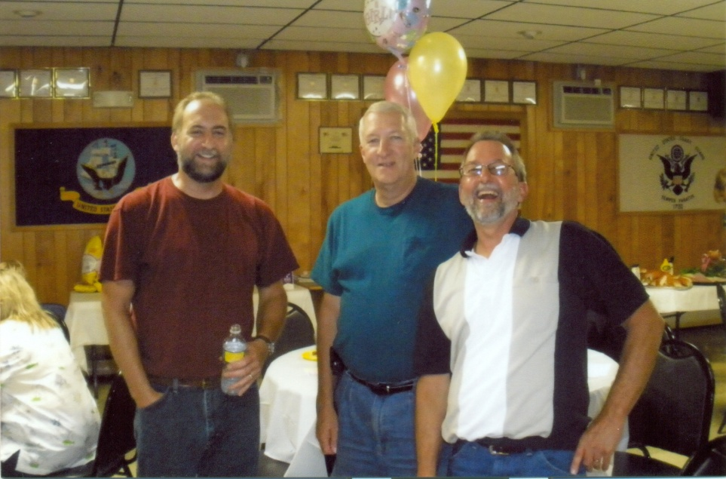
Just wanted you to know my daughter wore the Christening outfit you bought for me, at her Baptism. Just wanted you to know you will always be in my thoughts and memories. Just wanted you to know we are all grateful to have those last few memories with you at Grandmas gathering.
I am so glad we had a special connection. That day August24, 2012 a piece of my heart broke!
Just wanted you to know I Love You And Miss You! I just wanted you to know you are always in my heart!
I thank my mom for taking all these great pictures so I could remember you!
Love, Aileen

U.N.C.L.E
By: Sherri-Ann LaVallee (niece)

Unique voice
Never ending supply of gum
Center of attention
Lived every moment to the fullest
Excellent in every way!
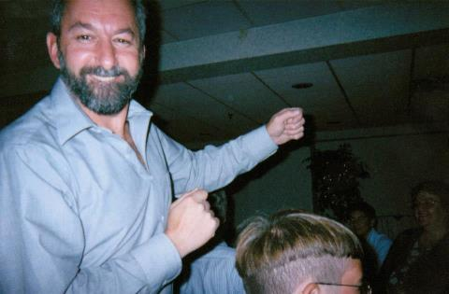
I was the Luckiest!
By: Steve Palermo (nephew)

I guess as far as the nephew's go I have to consider myself the luckiest. I was fortunate to live literally next door to Uncle Tom for many years as a kid. I was very young at that time but still have some very vivid memories of him as he was so impressionable as you all know.

The first memory I have of him was when I was maybe 4 or 5, Uncle Tom, my Dad, and Grandpa were working on Grandpa’s old Backhoe tractor in Tom's driveway at the Morrison Road house. They were welding something and as you know while welding you have to wear a face shield or the bright light from the welding arc could blind you. They knew I would want to get in on the action, so to keep me out of harm’s way they put me in the backseat of Grandpas car to keep my distance. Being a curious kid I just had to try to watch what these 3 were doing and took a "peek" out the rear window. Uncle Tommy saw me and didn’t want me to go blind, so he had Grandpa stop what he was doing while he proceeded to go inside to get something. A minute or so later he returned with a whole package of Andes Candies - you know, the little chocolate mints - and gave them to me to eat in the car, as long as I promised not to look at the welding arc...LOL. I think I ended up eating the whole package! Still crave those mints to this day!

Another year, there had been a heavy snowfall around Christmas, and Uncle Tom knew I wanted a metal saucer sled as a Christmas present. Well, Santa came and went but no sled... so... Christmas night, he came over to visit and “low and behold”, he had a nice shiny blue metal saucer sled with him! He told me Santa left it at his house by accident! I had that thing for years - I used it as a sled, a shield, tied rope to the handle to pull things around on, used it as a roof for forts - you name it, I used it for! I think we finally got rid of it after I had literally worn a hole in the bottom of it! I will never forget that sled... or Uncle Tom!

When he had moved to Derry he still came over quite often, as he had an old car, a "Plymouth" I believe, that he was working on in my Dad’s garage. When he first brought it there it looked like the sloppy jalopy... but he spent countless days weeks and months working on that thing and he ended up with a beautiful car when he was done. It was candy apple red (first time I had heard that color was from Tom) and I remember going for rides in it up to "Hardies" old country store for donuts and cocoa! I think the best part of that experience was spending time with him and watching him tear the car apart and put it back together. I learned a lot from him then and still put those skills to use this day. I guess maybe that's where I got my love to "tinker" from... or was it from my Dad? - maybe Grandpa? I guess it just runs in the family! Oh, I can’t forget the night we were working on the car in the garage and Aunt Betty brought us pizza... it was a small thing, but for some reason it sticks in my head… Good times!

OH!!!!!!!!!!!!!!!! I can’t believe I almost forgot this one! There was (and still is, I believe) a big bush out in the field area behind his Morrison road house... and Uncle Tom wanted to pull it out of the ground, so he chained it to the back of Grandpa’s Backhoe Tractor and proceeded to tug, yank, and pull at this thing with no avail. He finally gave up (which was rare for him) but as time went on the tree which was damaged during the process began to grow a little funny... it was almost split in half and as it grew it looked like...well...how do I say it... umm... let’s just say Uncle Tom called it the "Boob Tree" ! LOL Sorry, you can take this story out if you want but I had to write it - if for no other reason, to give Uncle Tom a laugh if he's watching me type this!

As I got older I was able to spend many nights at Tom and Betty's place in Derry...I remember watching them put big puzzles together to put up on the wall in frames, I remember watching him put up the pool in the back yard, the deck, the shed. He was ALWAYS working on SOMETHING!! Their house being at the top of that big hill, came in useful as he sometimes had to "roll / jump" start that old red car on his way to work… LOL. I always wondered what would have happened if it didn’t start...nah... never happened! Then in 1988, I believe, I saw Uncle Tom go through many emotions... He was blessed with the Birth of Mario... and the passing of Grandpa. I think these were the only 2 times that I saw him cry.

So as some of you may know, I am a big NASCAR fan (Go Carl Edwards!!) anyway, Uncle Tom and Aunt Betty always took me to Hudson speedway on Sunday nights to watch the races... and for that, I am thankful - as I think it really shaped part of who I am today. The best was going to see the "Joey Chitwood, stunt spectacular" I know Betty remembers this... LOL… Good times for sure... I will never forget the smell of burning tires, race fuel, fried dough and pretzels! I had returned there a few years ago to take Jessica... I had always told her about the time I spent there with Tom. Unfortunately, as with most good things, it had taken a turn for the worse and the whole track was run down and falling apart... Maybe it was just because Uncle Tom wasn’t there with us that made it seem so bland? I can hear the announcer in my head now from one of the demolition derby nights... "Twisted mounds of metal"! Tom always showed me how to pick the drivers who he thought would win... he always told me not to pick the cars with “the nicest paint job”, since they put all their money into how the car looked instead of how it ran - an important life lesson! "It’s not what’s on the outside that counts... Its what’s on the inside!" Anyway... Thank you Tom for the track memories and my love for all things that go fast!

Then one day, I got word that they were moving to Hillsboro, NH. WHAT? That’s a far drive! (Well… it seemed far, for me, as a kid! ;) Never fear though, Tom and Betty were always willing to have me come up on a weekend to spend time with them there too! I appreciate everything they did for me as a kid. Tom and Betty both really brought about some real big changes in me as I was growing up and I will always be thankful for that. Thank you for treating me as your own!

And, finally my last memory of Uncle Tom…
So, as you all know, I have been in the Military for over 16 years... I have been here in Virginia the whole time and it’s hard to get home sometimes with deployments, and regular work and schedules etc. Well “Good Ol' Tom” didn’t let that stop him! He and Betty made sure to make it a point to come visit while they were in the area for Garrick’s Graduation at Ft Eustis, and then the last visit he made with Betty, Jake, Jakes girlfriend and the 2 dogs!

We spent a nice afternoon walking down the boardwalk here in Virginia Beach with the dogs just talking laughing, and catching up. We stopped at a pizza place to grab a bite and Tom had bought some meatballs for the dogs to eat. What dog doesn’t like a meatball right? The waiter brought out our pizzas and the meatballs and the dogs just looked at them not knowing what to make of them. They were the size of baseballs! There were lots of jokes thrown around the table that day and plenty of smiles had by all. I got to talk to Uncle Tom alone about some random things, got some good advice, and got to give him a couple big hugs. Thank you for taking the time to go out of your way to come visit us.... It really meant a lot and I am glad to have my last memory of you such a happy one!

Steve

Uncle Tommy Memories
By: Stephanie Palermo (niece)

I remember Uncle Tommy always being so goofy with us as kids. Brittany
may have this same story but one time at one of the big family yard
sales we had at grammar’s house, I accidentally called Uncle Tommy, dad,
because they looked so much alike. Brittany and I were laughing hysterically, and he just played right along.
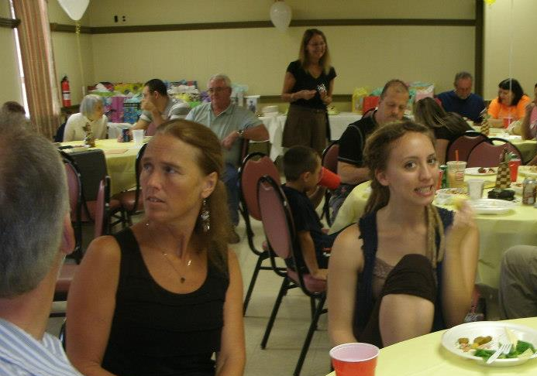
Another great moment with Uncle Tommy was when my dad and I were visiting gramma on a Sunday morning. Uncle Tommy stopped by unexpectedly with an old VHS tape of grandpa sitting at the table in the old house, talking and laughing etc. I'm so grateful he decided to stop by. It was the only time I got a chance to see grandpa in action, thank you for that Uncle Tommy! And thank you for going out of your way to come to my high school grad party. And, for all the things you've ever done when I was younger - that I perhaps don't remember or know about.

A Letter from Heaven
“Tom is in our every Tomorrow”

When Tomorrow starts without me
And I’m not here to see
If the sun should rise and find your eyes
Filled with tears for me
I wish so much you wouldn’t cry
The way you did today
While thinking of the many things we didn’t get to say
I know how much you love me
As much as I love you
And each time you think of me
Know that I’ll miss you too
When Tomorrow starts without me
Don’t think we’re far apart
For every time you think of me
I’ll be right there in your heart

Danielle Chernick (niece)

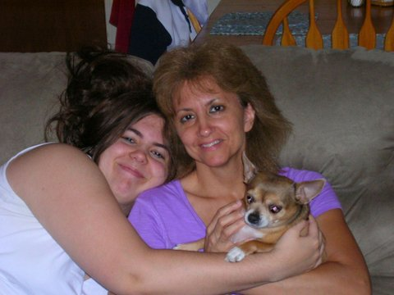

"I've known Uncle Tom for so long. I've always enjoyed the good times we spent together, especially hearing him telling stories to make us all smile and laugh. I know he's in a better place now. I'll pray for him and hope he is at peace. I will love him forever.

love,
Danielle

“ Tumbling…”
Sean Carroll (nephew)
My main memory of Uncle Tom was when we came to NH to visit for our annual trip and he took us (Diana, Andrea, and I) to the amusement park. I was pretty young, maybe 6 or so, and I want to say it was Salisbury Beach.

I remember going out there in his car, which I think was one of those big old cars (like a Ford LTD or something like that), maybe a convertible.

We got out there and had a great time, and there was even a fun house. So, we all go through the fun house and are having a blast, and toward the end of the fun house there is the big spinning drum-thing that you have to run through.

Problem is, when you are 6 you don’t have a firm grasp of physics, and you don’t understand that in order to successfully make it through this thing, you have to keep your feet moving. So I start to go through it slowly and guess what, of course I fall down but the drum keeps turning.

So here I am, 6 years old, stuck in this spinning drum, and I start tumbling around like laundry in a dryer. I’m literally riding up one side of the drum -and then tumbling over - and down again toward the bottom of the drum.

Nowadays, I’m sure they have someone sitting there to prevent things like that (and lawsuits) from happening, but this was the 1970’s here.

So I’m tumbling around like underwear, and out of nowhere I see this hand reach in and grab my arm to save me.

It was Uncle Tom. I’m gonna miss him. I never got a chance to tell him “Thanks”.

Without him, I’d probably still be stuck there, tumbling . . .

Sean

“Take care of my little sister…”
John Robinson (brother-in-law)

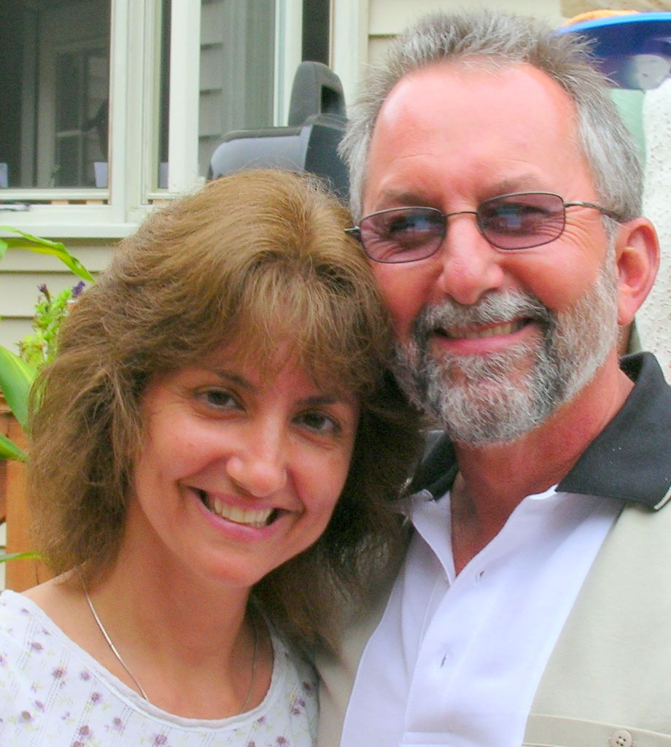

Tom was a great guy and I was glad to have him for a brother-in-law. I wish I had known him longer than I did.

My last memory of Tom was his smiling face that Saturday (August 18, 2012) at the Palermo Family Gathering as he hugged his sister, my wife Theresa, just as we were leaving - he looked me in the eyes and said, "Take care of my little sister Theresa!"

I will take care of her Tommy, you can rest assured, I will. - Be at peace - you are well loved and will be greatly missed by all who knew you.
~
John Robinson
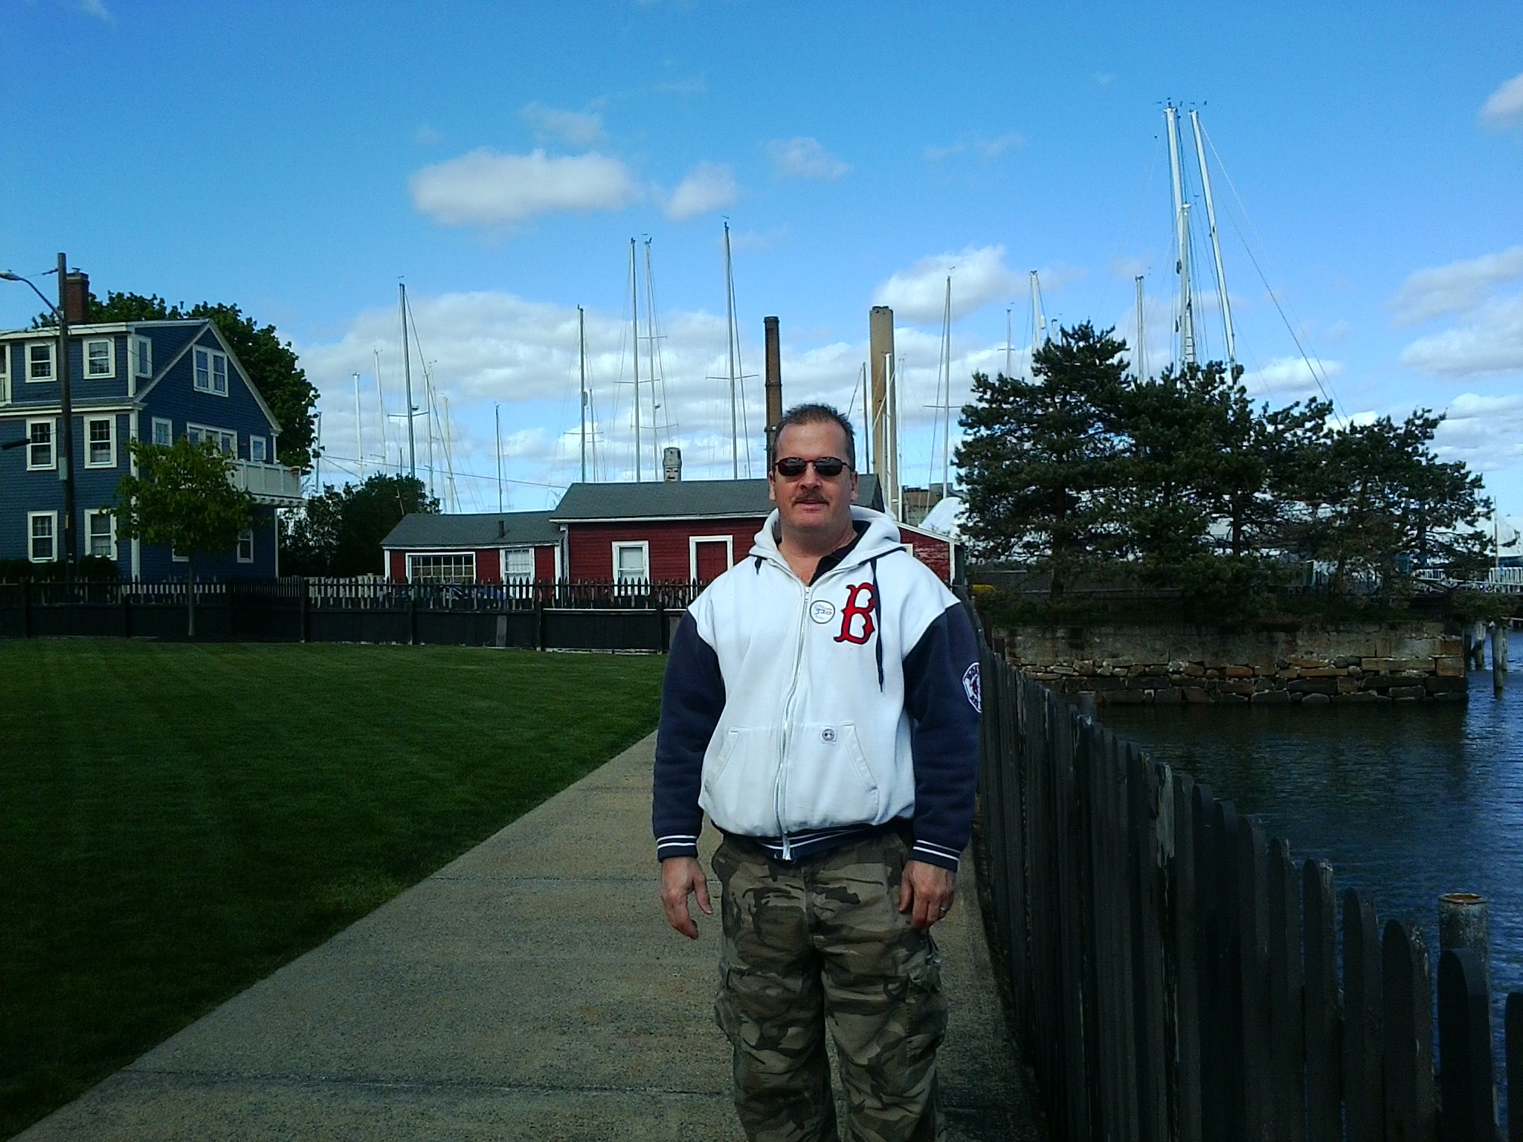

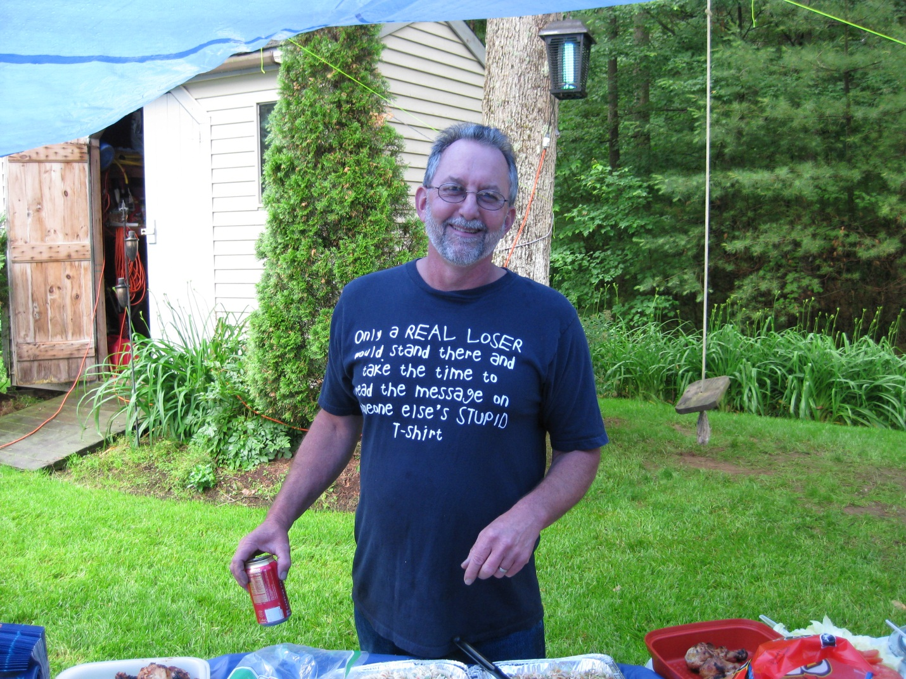

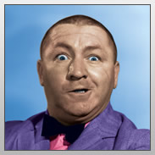
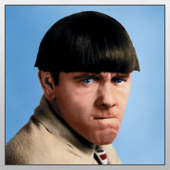
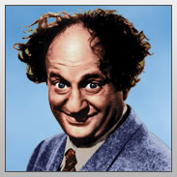

NYUK! NYUK! NYUK!

